Duplication Management

Friday, November 19, 2021

There are no front-end logs.

Would we be able to obtain access right.

* No one on my team can accept logs.

Machine generated alternative text:
SQuirreL SQL Client Version 37 
Viewing Nijesh Narayanank.. 
E" Qrwers A.ases 
E RR_coz 
0 
as 
as 
usG_0T_ ruE 
1-18 22.36.0048 
2 - PRN-L-.ppsæ•psvc as 
usG_oesc 
Rows 
Rows: COW O 
• rom • 
R.suns 
SOLState nun 
4223 
• —sq_dt_ 

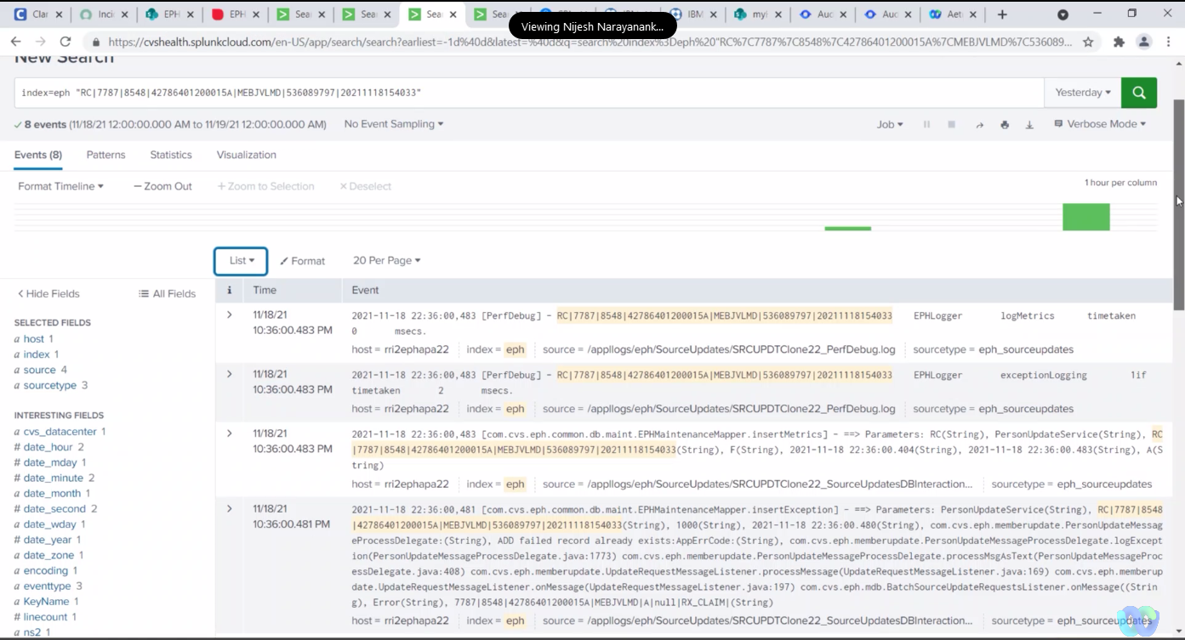

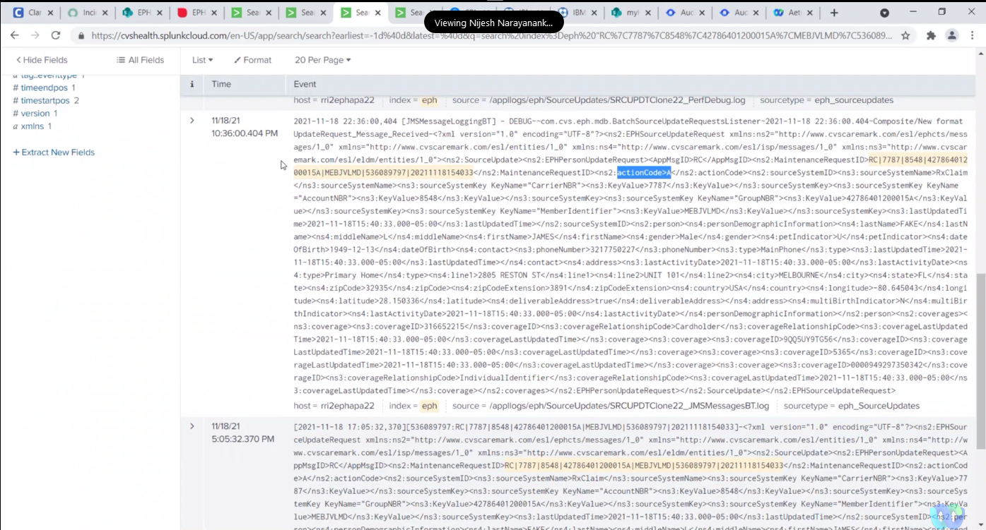

Walk us through system functions to see:

* if it existed
* And see if it failed

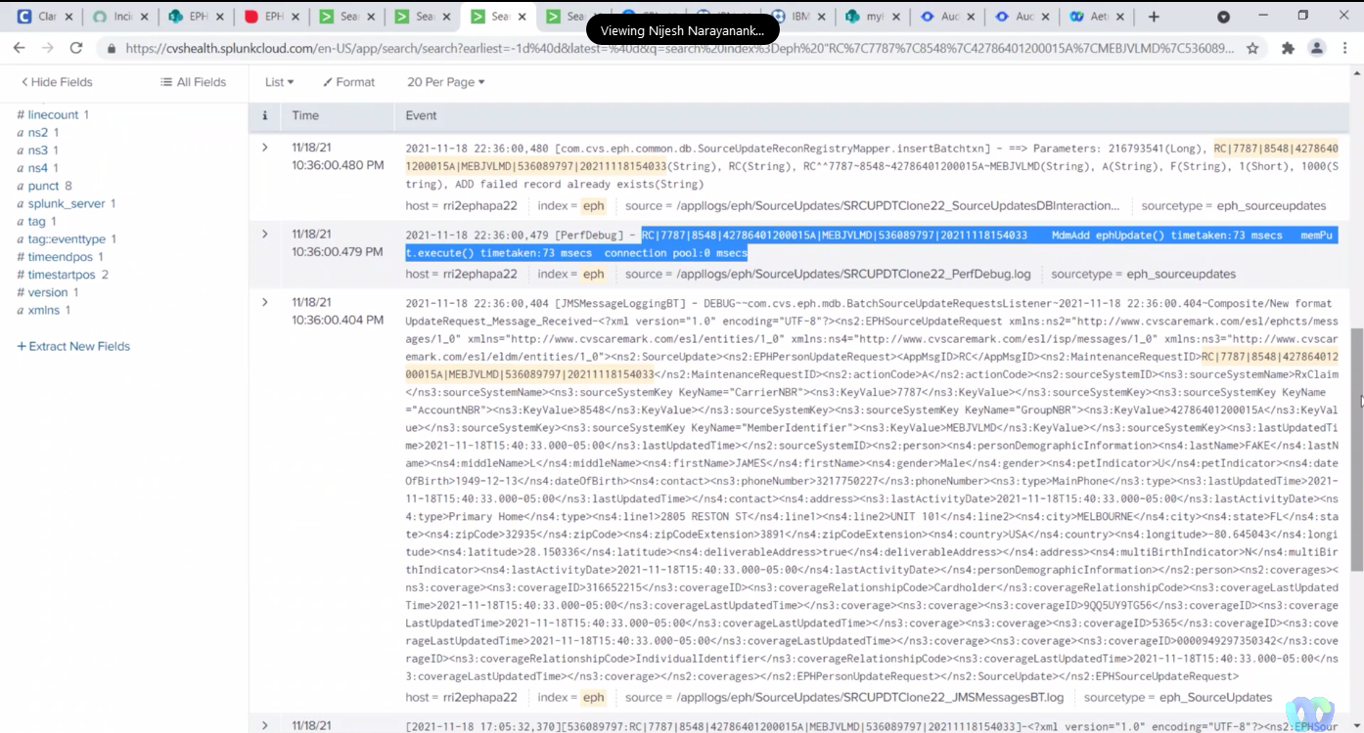

The batch feed came in from Rx claim, to add a record. Given the record already existed. So the time out - was the add failed record - 1000.

Can we look at it from if no duplicate exists?

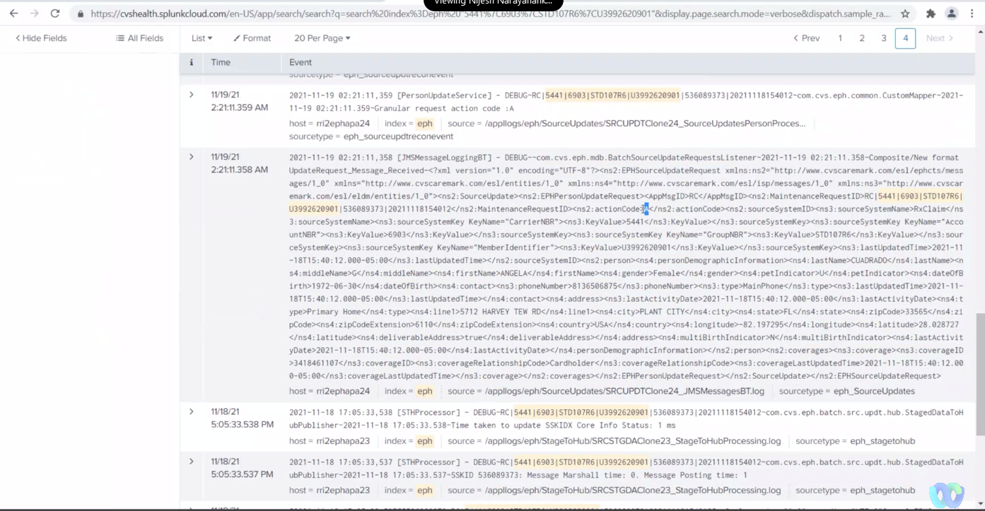

What are the various action codes.

* AUD - Add, update, Deleted.

RxClaim ID from the source

Machine generated alternative text:
IV19/21 
11,'19/21 
221:12.313 AM 
11/19/21 
lt.'19/21 
AM 
It'19/21 
AM 
lt.'19/21 
AM 
It,'19/21 
AM 
035881 . maudRecNo: 3054035881 , ssQuaI ifer : RC , memi dNum: 5441-6903-STD107R6-U399262øgO , rwdIxnType Add. curEntRecNo , g»stIxnSuccess fal se , linkIDChange : fal s 
host = rri2ephapa24 index- eph source sourcetype= eph_sourceupdates 
313-postOutYemrOasToIxnProcess: Invoked with ; 
Begin Ounp; IMemHead rowlnd:l entRecnO:O 1974819723 memSeqno:IO cAudRecnO: 3054035881 
mAudRecno: 3054e35881 srcFtime: srcLtime: recCtime:2ø21-II-19 02:21 recYtime:2021-II-19 rnStat:A memVerno:e srcRecno:13 memldnum: 
5 : ink Type: I End Add 
host = rri2ephapa24 index eph source = "applIogs/eph/SourceUpdates/SRCUPDTaone24_PostIxnProcess.Iog eph_sourceupdates 
-2021-1 1-19 02:21 : 12.313—Before calling postim process 
host rri2ephapa24 index eph source z 'appllogs/eph/SourceUpdates/SRCUPDTCIone24_SourceupdatesPersonProces... 
sourcetype eph_sourceupdtreconevent 
aSetup-2021-II-19 02:21: .359-Received request to set Mobile phone values 
host rri2ephapa24 index z eph source 
sourcetype eph_sourceugxttreconevent 
aSetup-2021-II-19 02:21: .359-Received request to set Coverage values 
host = rri2ephapa24 index eph source z 
sourcetype eph_sourceupdtreconevent 
aSetup-2021—II-19 02:21: .359-Received request to set LOC values 
host rri2ephapa24 index = eph source z 
sourcetype eph_sourceusxftreconevent 
2e21-11-19 [Personupdateservice] 
- INFO-RC15441 STD1e7R6103992620901 1536es937312e211 
aSetup-2021-11-19 02:21: . request 
to Set HCC values 

The Splunk logs show for each individual activity.

New CVS ID created (walk through)

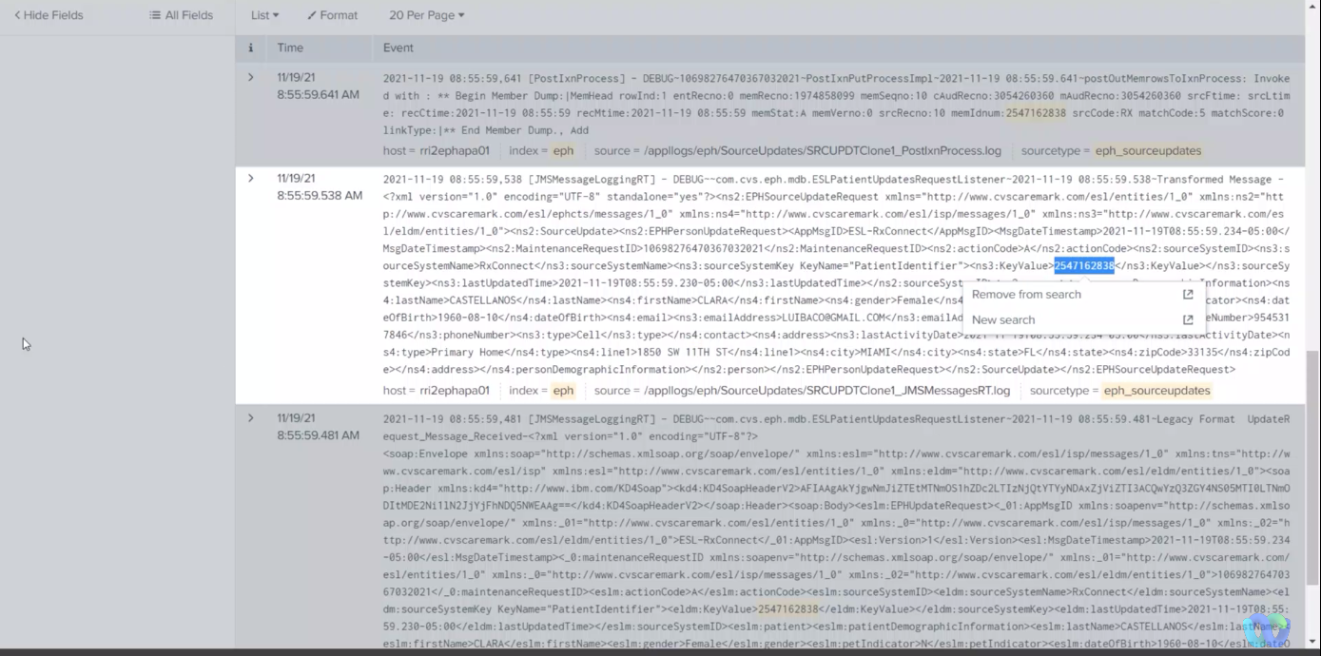

Action Code

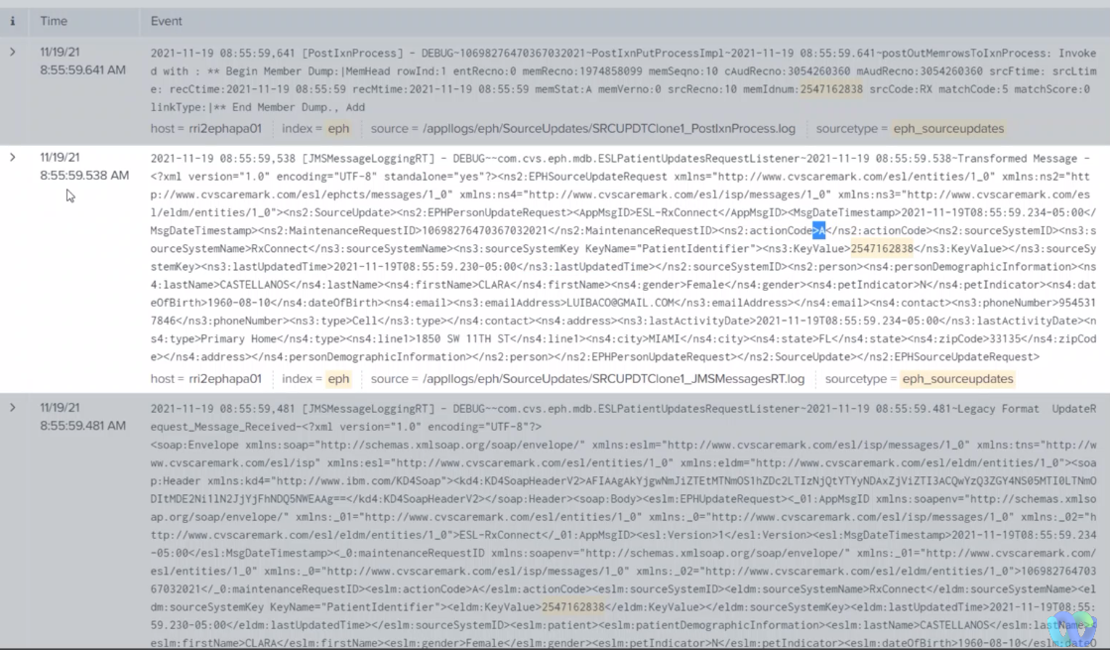

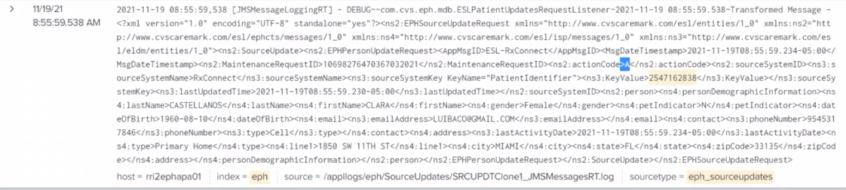

The record - 2547

Machine generated alternative text:
m as 
7 - Prod-L as 
gia from ] i nK_iZ = an a '2547162838' 
link, 
select • trom m 
uetaO.ta as 
Rows: COW O 
0 Reatn 
CREATE 0_orTv 
results 0027 

Machine generated alternative text:
select nwnmum • trom m 
Resuns 
Rotated t." 
CREATE 0_orTu 

Already had an ID in system. Source system data came into EPH the day before, but a new CVS ID was not created because the individual already had a ID.